
Cam Bulldogs FC

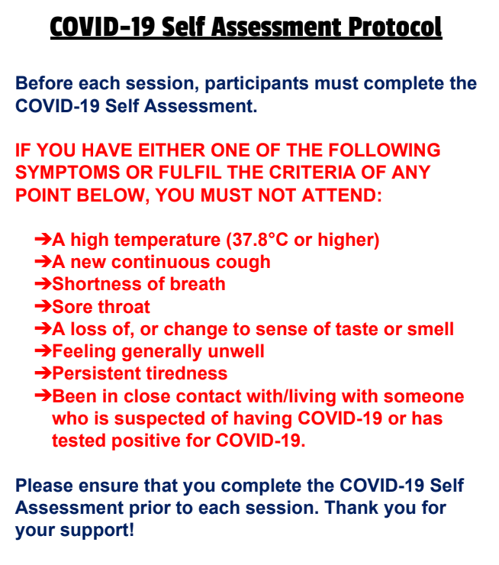
Doug Walton - COVID-19 Club Officer
07805263611

